Otters at Play

Brandon Taylor (Coral Glades High School)

Juan Cotes (Cypress Bay High School)

Carson Ramsay (Coral Springs High School)

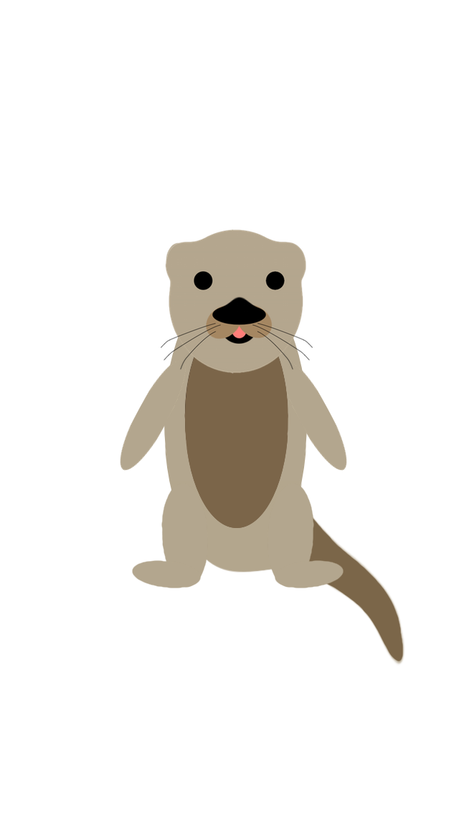

**Abstract**

The Museum of Discovery and Science provides an interactive experience for visitors of all ages in its many exhibits. A major attraction at the museum is the otter exhibit. This exhibit allows visitors to get a look at a species of animal that they may not have the opportunity to see anywhere else and it allows visitors to get up close to this exotic creature. Our intentions were to create an app that gave visitors the chance to learn even more about these magnificent creatures and to create an interactive experience for all.

**Background**

We are currently interns at the Museum of Discovery and Science. Our group applied for this internship in the middle of our junior year of high school with the hopes of learning valuable skills to implement throughout our lives. This internship incorporates all aspects of STEM learning in order to further our formal education. A principle aspect of this internship was to create a way to bring visitors to the museum into an interactive and technological environment that facilitated learning. The museum decided that in order to do this we were to create an interactive and educational android application that visitors to the museum may download. In order to accomplish this we were asked to enroll in an FAU class for the summer between our Junior and Senior years. This class has allowed all of us to create extremely well designed applications to be used by the visitors and to create well designed graphics to accompany our apps. In the beginning of the program we were asked to choose what exhibit we wanted to create our section of the app for. Our group knew right away that we wanted to research the otter exhibit to develop the application for because the otter exhibit is a very interesting exhibit and it is a crucial part of the museum. Also, we felt that we could improve on the exhibit by adding in a lot of factual information in our app.

**Methods**

When we arrived at FAU for the first day of class we were asked to divide the responsibilities of app development equally between ourselves. The team leader of the group was asked to work on the user interface portion of the application. The other two people in the group had to decide among the other two responsibility options of Java development and graphics development. Brandon Taylor was in charge of user interface, Juan Cotes was in charge of Java development, and Carson Ramsay was in charge of graphics development. In our group, Juan was responsible for posting assignments to the Github website in order to maintain an organized flow of assignment submissions. Brandon Taylor was in charge of designing the layout of the application activity screens and assigning buttons to these screens. Carson worked for the duration of the course on gathering images to insert into the application, creating a three-dimensional otter to rotate on one of the screens in the app, and designing the storyboard for our promotional video. Juan also worked on linking the different pages of the application in order to make the app interactive as well as making the quiz game provide the correct answers to the user. Many times we were faced with struggles to do very advanced actions with the small amount of experience that we had going into the course. Our two biggest problems with the development of our app were inserting three dimensional animations into the app and creating an interactive quiz game. In order to insert the 3-D animation we created a looping mp4 file and inserting that video into the app as a video view. In order to create the interactive quiz game we created a screen with 5 questions with a check answer button under each question. The check answer buttons link to a popup screen that displays the answer for that one question. These two problems took a long time to complete but eventually led us to create a higher quality app that we now have at the end of the course.

**Results**

Our app allows visitors to learn a vast amount of information about otters that they couldn’t learn at the exhibit. It includes an array of information going over the diet of otters, their behaviors, anatomy, etc.. and it includes numerous pictures to accompany the text. Most importantly, our app gives visitors an easy and concise way to learn about the otters in the exhibit.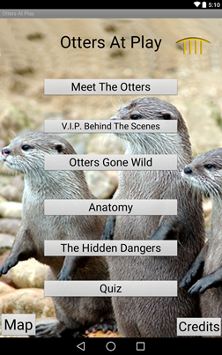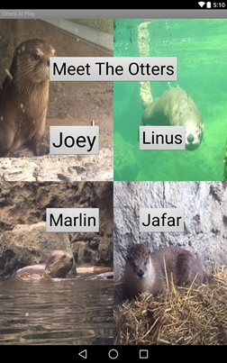

**Discussion**

We feel that we made all the extensions possible in order to make a complete app. We included an icon that properly relates to our exhibit and we created an app that goes over all of the information that we wanted to include regarding the lifestyle of otters (their diet, behavior anatomy, and dangers in the wild). We also added additions into our app to make it really stand out such as our interactive map and 3D moving otter.

**Conclusions**

We as a team are very proud of what we accomplished in our app. In only three weeks we amateurs were able to create a functioning app that included a plethora of information on otters and amazing graphics to accompany our text. We are very proud to call our app a part of the museum of discovery and science. This opportunity for us to learn android development and design and Florida Atlantic University has been a great experience for us and has allowed us to expand our minds to the opportunities of the world.

**Acknowledgements**

We received information about the otters and pictures of each otter from the museum of discovery and science. We would like to thank our Fau teachers (Ravi Shankar and Francis McAfee) along with Demetrius Dukes and Santiago Aguerrevere for assisting us in the making of our app. We would also like to thank Summer Scarlatelli and Joe Cytacki of the Museum of Discovery for giving us the opportunity to be a part of this program. Lastly, we give a special thanks to United Way for giving us the resources to allow this program to even exist.

**References**

Thank you to the discovery center group for giving us the cartoon otter. We received information about the otters and pictures of each otter from the museum of discovery and science. We also used code from Ravi Shankar, Alain Edwards, and the Android Studio Development book. We would like to thank our Fau teachers (Ravi Shankar and Francis McAfee) along with Demetrius Dukes and Santiago Aguerrevere for assisting us in the making of our app. We would also like to thank Summer Scarlatelli and Joe Cytacki of the Museum of Discovery for giving us the opportunity to be a part of this program. Lastly, we give a special thanks to United Way for giving us the resources to allow this program to even exist.